No. | Git Command | Description
 | git init | Initializes a new Git repository in the current directory.
 | git add | Stages changes (files) to be included in the next commit.
 | git status | Shows the current state of the working directory and staging area.
 | git add <file> | Adds a specific file to the staging area.
 | git commit -m "message" | Saves staged changes with a message describing the commit.
 | git log | Displays the commit history.
 | git checkout <branch/file> | Switches branches or restores files.
 | git diff / git diff chapter3.txt | Shows differences between commits, branches, or files.
 | git branch | Lists, creates, or deletes branches.
 | git merge <branch> | Merges the specified branch into the current branch.
 | git clone <url> | Copies a remote repository to your local machine.
 | git pull | Fetches and merges changes from a remote repository.
 | git push | Uploads local commits to a remote repository.
 | git remote -v | Shows the remote connections (URLs) for the repository.
 | git reset | Unstages files or resets commits.
 | git rm | Removes files from the working directory and staging area.
 | git rm --cached -r . | To re  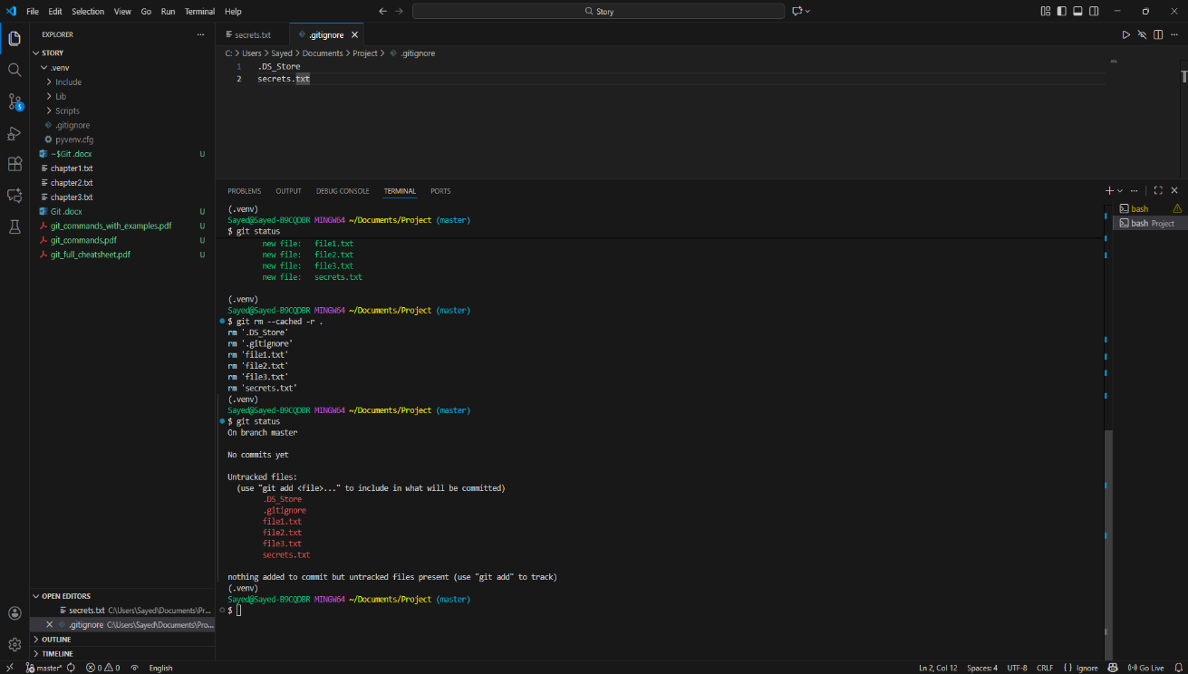
 | #Log Files  *.txt | All the txt files will be ignored in .gitignore
To create a new branch git branch (Branch Name) – git branch to check branches
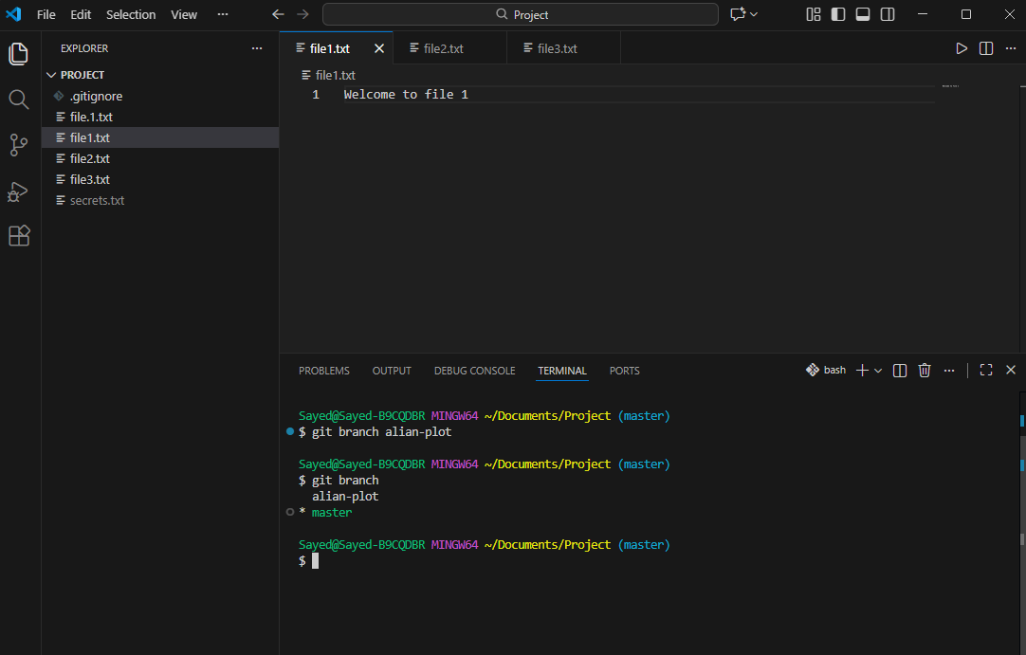
Git checkout alian-plot to switch to alian-plot branch
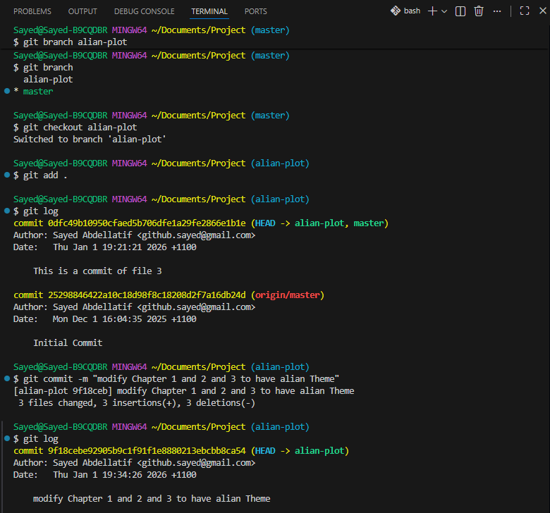
 | Git merge branchName | To get merge go back to master or main branch then enter then write :q! then enter  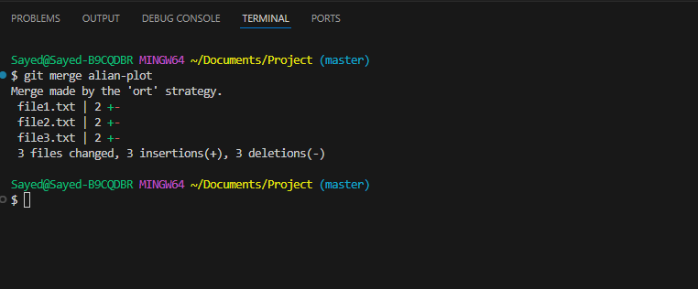
 | git push origin master -u | To push what I have done to original GitHub

